11.3 Quadratic Functions and Their Graphs

Graphs of Quadratic Functions
The graph of the quadratic function
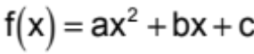, a ≠ 0
is called a parabola.

Important features of parabolas are:
- The graph of a parabola is cup shaped.
- The graph opens upward if a > 0 and downward if a < 0.
- The vertex is the turning point of the parabola.
- If the parabola opens upward, the vertex is the lowest point on the graph.
- If the parabola opens downward, the vertex is the highest point on the graph.
- The graph of the parabola is symmetric to the vertical line that passes through its vertex.

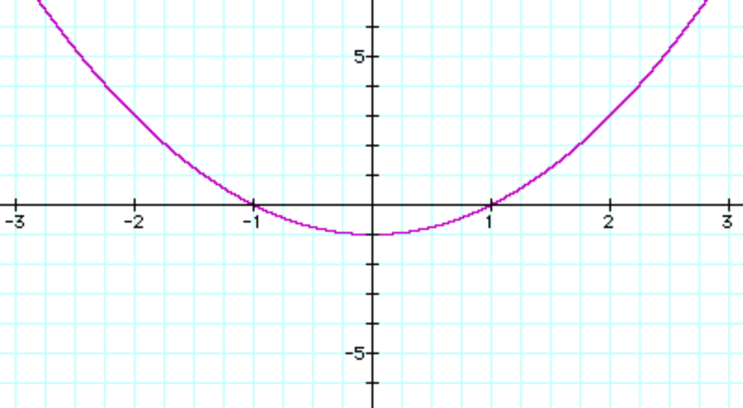
Graphing Quadratic Functions in the Form 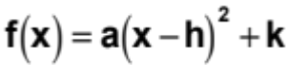.
To graph 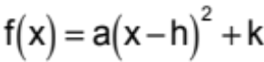:

1. Determine whether the parabola opens upward or downward. The graph opens upward if a > 0 and downward if a < 0.
2. Determine the vertex of the parabola. The vertex is (h,k).
3. Find any x-intercepts by replacing f(x) with 0. Solve the resulting quadratic equation for x. The x-intercepts are the points 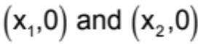 where 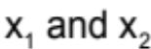 are the solutions.
4. Find the y-intercept by replacing x with 0 and solving for y. The y-intercept is the point (0,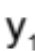) where is the solution.
5. Plot the intercepts and vertex and additional points as necessary. Connect these points with a smooth curve that is shaped like a cup.

Example 1: Graph 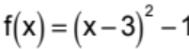

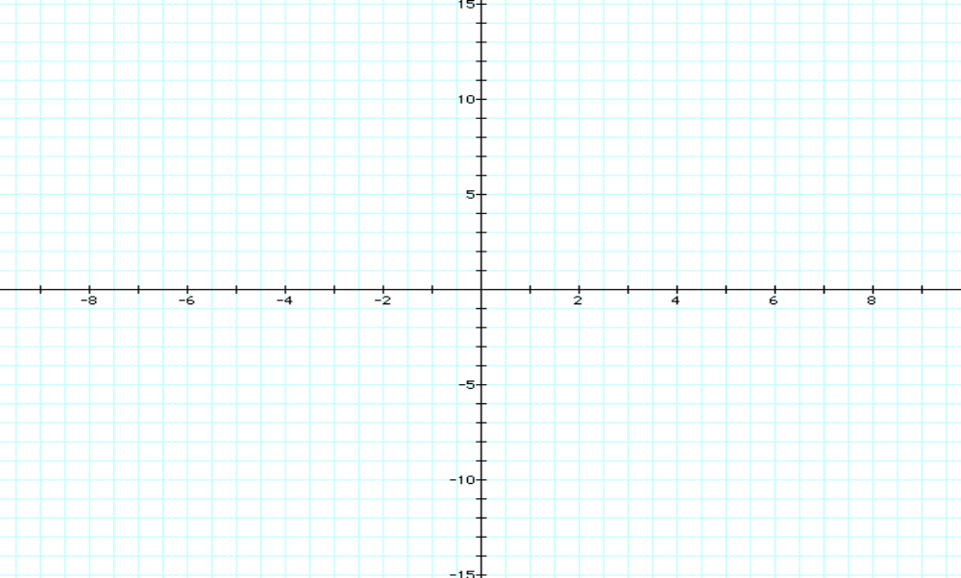
Example 2: Graph 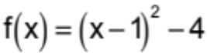

Example 3: Graph 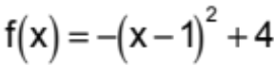

Example 4: Graph 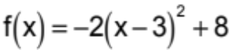

Graphing Quadratic Functions in the Form 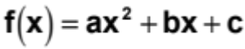.
To graph :

1. Determine whether the parabola opens upward or downward. The graph opens upward if a > 0 and downward if a < 0.
2. Determine the vertex of the parabola. The vertex is 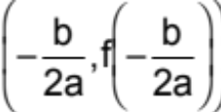.
3. Find any x-intercepts by replacing f(x) with 0. Solve the resulting quadratic equation for x. The x-intercepts are the points where are the solutions.
4. Find the y-intercept by replacing x with 0 and solving for y. The y-intercept is the point (0,) where is the solution.
5. Plot the intercepts and vertex and additional points as necessary. Connect these points with a smooth curve that is shaped like a cup.

Example 5: Graph 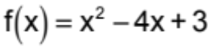

Example 6: Graph 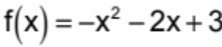

Example 7: Graph 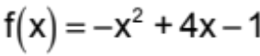. Use your calculator to approximate the x-intercepts to the nearest tenth.

Applications of Quadratic Functions
Consider .

1. If a > 0, then f has a minimum value that occurs at 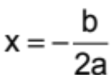.
The minimum value is 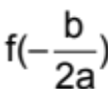.
2. If a < 0, then f has a maximum value that occurs at .
The maximum value is .

Example 8: Use your calculator to find the maximum or minimum value for each of the following quadratic functions.
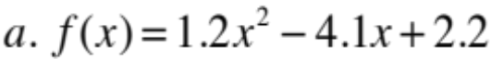

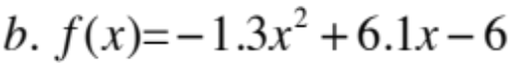

Example 9: A person standing on the ground throws a ball into the air. The quadratic function
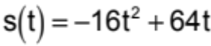
models the ball’s height above the ground, s(t), in feet, t seconds after it has been thrown. What is the maximum height that the ball reaches?

In some verbal problems, the quadratic functions are not given, but must be formed. In these cases, follow the strategy below to solve the problem.
Strategy For Solving Problems Involving Maximizing or Minimizing Quadratic Functions

1. Read the problem carefully and decide which quantity is to be maximized or minimized.
2. Use the conditions of the problem to express the quantity as a function in one variable.
3. Rewrite the function in the form .
4. If a > 0, f has a minimum value at . If a < 0, f has a maximum value at .
5. Answer the question posed in the problem.

Example 10: You have 100 yards of fencing to enclose a rectangular region. Find the dimensions of the rectangle that maximize the enclosed area. What is the maximum area?

Answers Section 11.3

Example 1:
The parabola opens upward.
The vertex is (3, −1)
The x-intercepts are (4,0) and (2,0).
The y-intercept is (0,8).
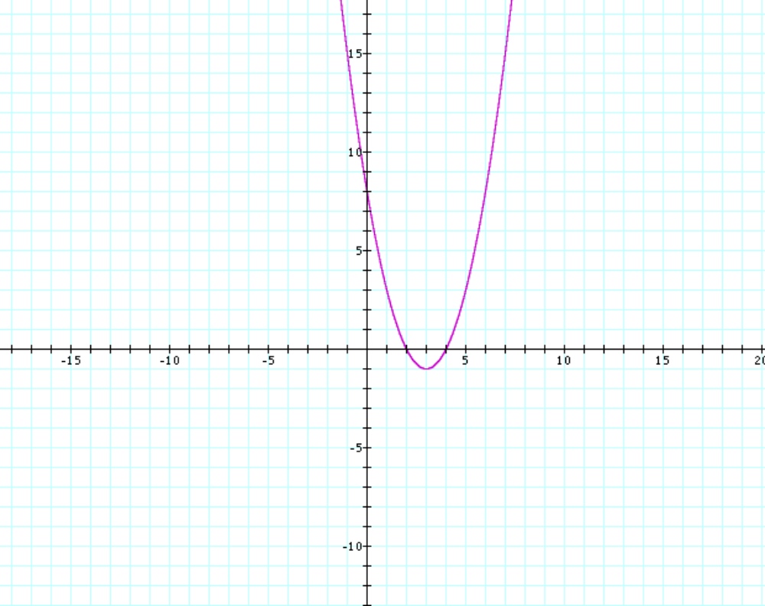
Example 2:
The parabola opens upward.
The vertex is (1, −4)
The x-intercepts are (3,0) and (−1,0).
The y-intercept is (0,−3).
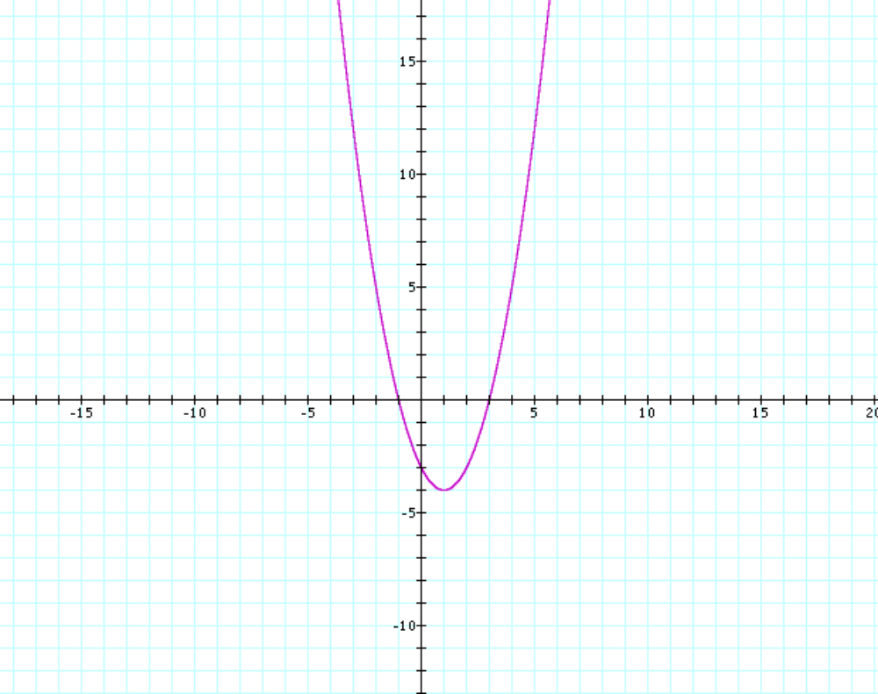
Example 3:
The parabola opens downward.
The vertex is (1, 4)
The x-intercepts are (3,0) and (−1,0).
The y-intercept is (0,3).
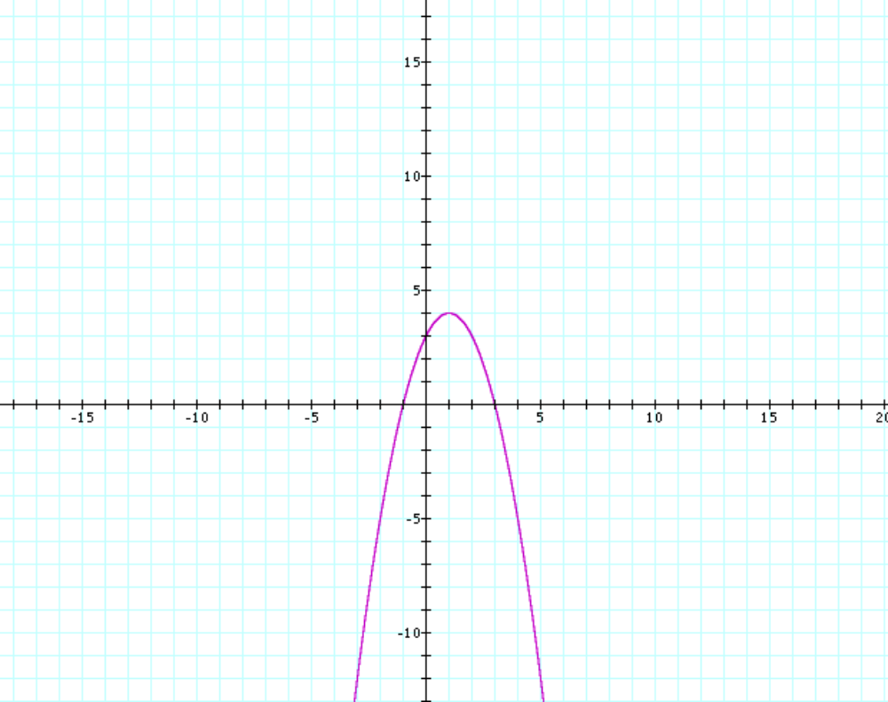
Example 4:
The parabola opens downward.
The vertex is (3, 8)
The x-intercepts are (5,0) and (1,0).
The y-intercept is (0,−10).
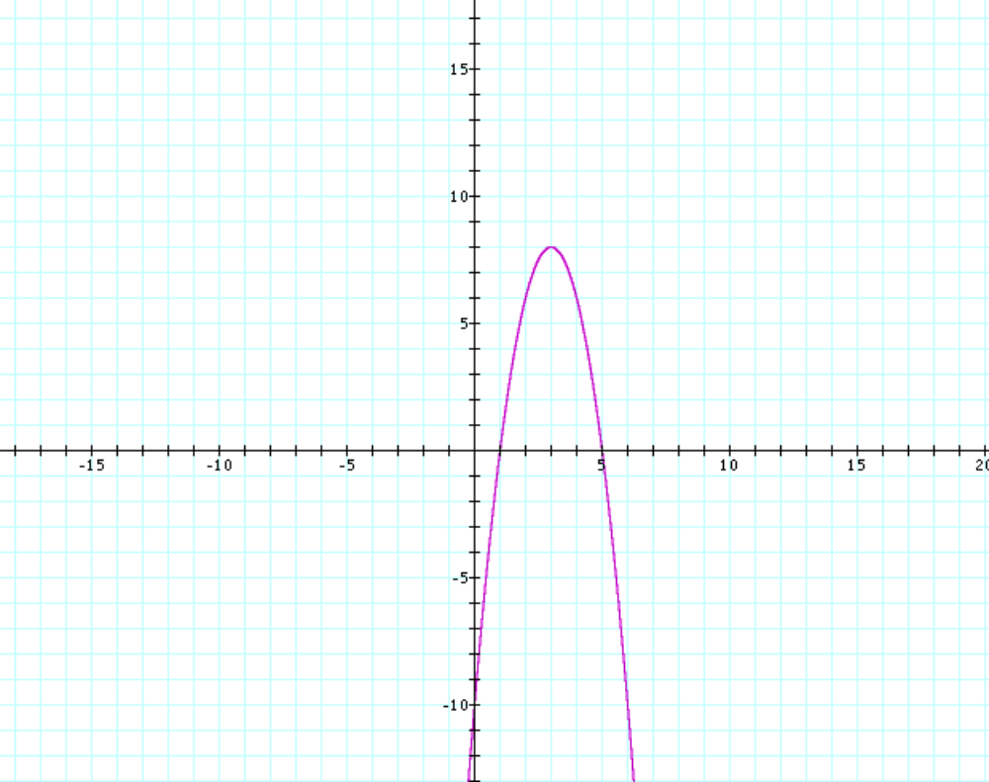
Example 5:
The parabola opens upward.
The vertex is (2, −1)
The x-intercepts are (1,0) and (3,0).
The y-intercept is (0,3).
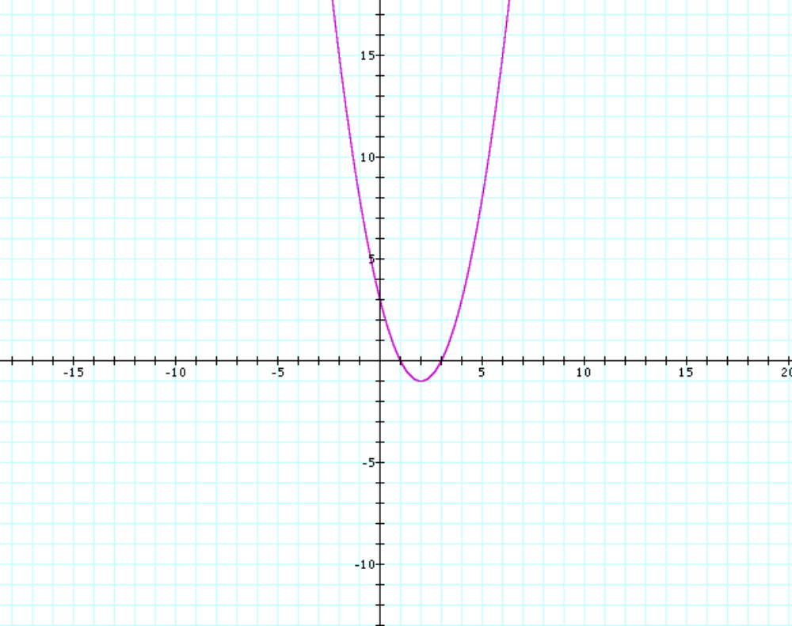

Example 6:
The parabola opens downward.
The vertex is (−1,4)
The x-intercepts are (−3,0) and (1,0).
The y-intercept is (0,3).
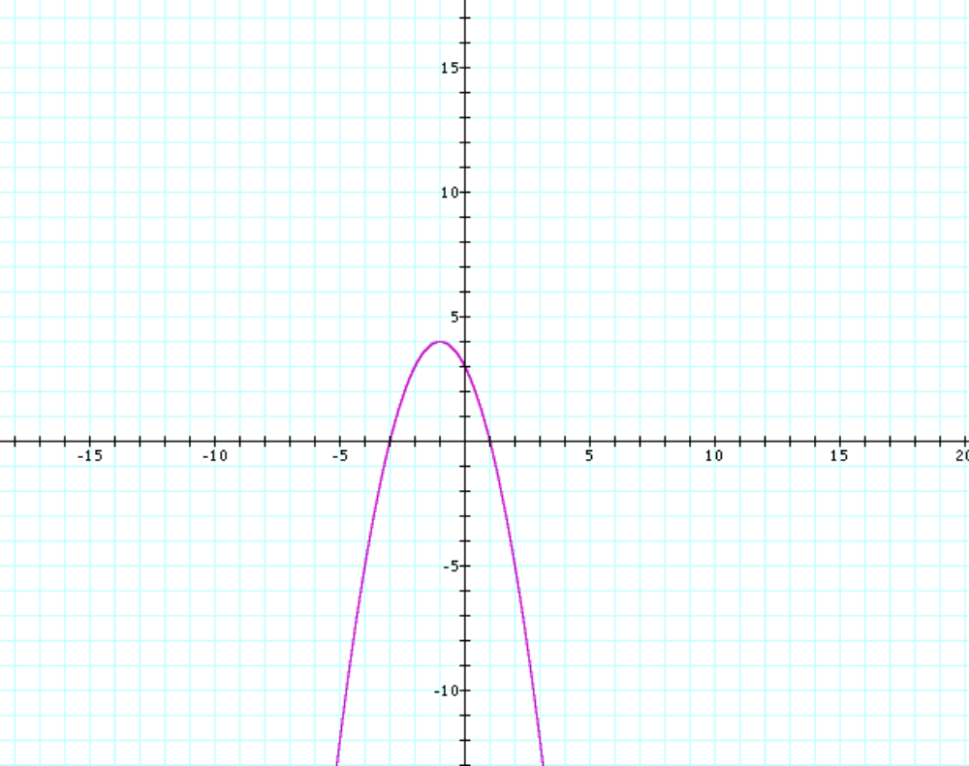

Example 7:
The parabola opens downward.
The vertex is (2, 3)
The x-intercepts are 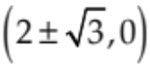 or approx. (3.7,0) and (0,0.3)
The y-intercept is (0,−1).
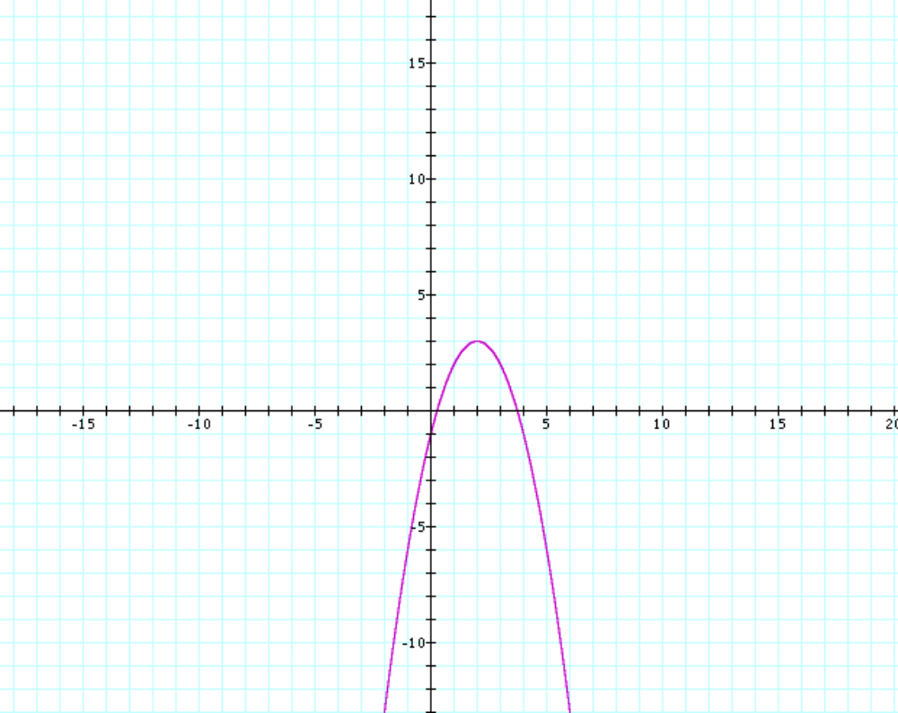

Example 8:
a. Minimum value is −1.3.
b. Maximum value is 1.2.

Example 9: The maximum height is 64 feet (the y-coordinate of the vertex).

Example 10: The dimensions of the rectangle of maximum area are 25 yards by 25 yards. The maximum area is 625 square yards.

