NERVOUS SYSTEM

List of model photographs :

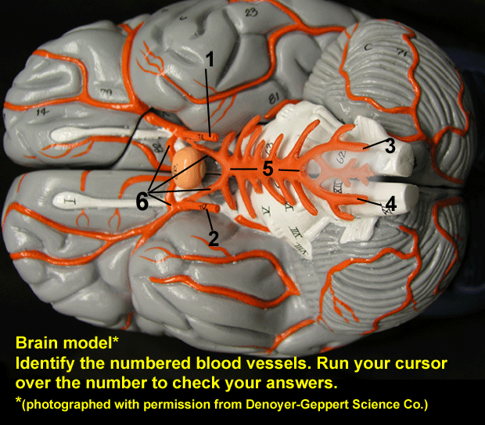 Blood vessels of the brain (inferior view)

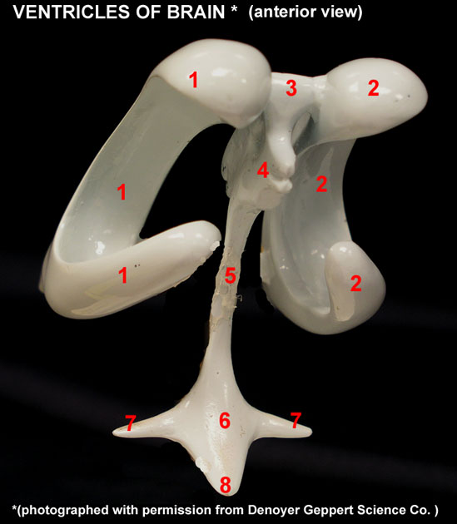 Brain Ventricles model (anterior-lateral view)

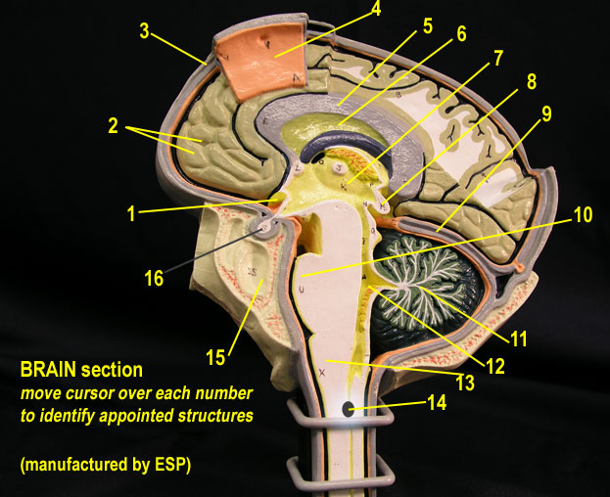 Brain section model (mid-sagittal view)

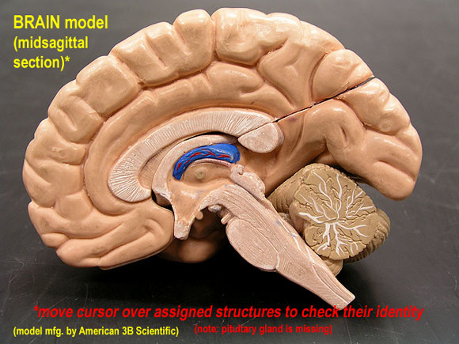 Brain model (mid-sagittal view)

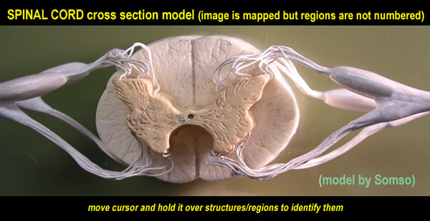 Spinal Cord cross section (Somso)

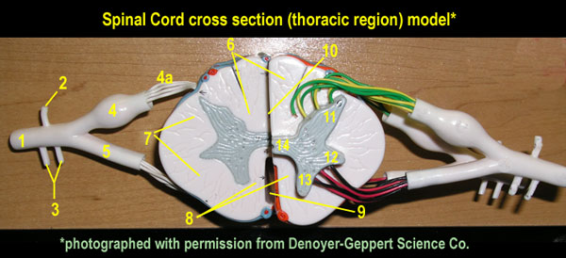 Spinal Cord cross section (Denoyer-Geppert)

