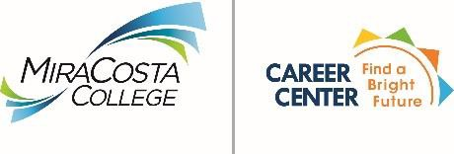
On-Campus Recruiting Policies for Employers

The staff at MiraCosta’s Career Center thanks you for your interest in recruiting our students and graduates through our campus recruiting program. We ask that you take this opportunity to familiarize your recruiters with our policies and procedures regarding campus recruiting. MiraCosta College is committed to equity, diversity, and inclusion. Please review our commitment statement at MiraCosta College's Commitment Statement.

Employers are expected to be familiar with and to honor the Principles for Professional Conduct for Career Services and Employment Professionals of the National Association of Colleges and Employers (NACE). If you would like to read the Principles for Professional Conduct document in its entirety, you may find it on NACE’s web site at http://www.naceweb.org/principles/

** Please note: Recruiters are limited to two visits per month per campus. Also, one point of contact per employer**
While recruiting, employment professionals and employer representatives will:

- Practice professionally accepted recruiting, interviewing, and selection techniques.
- Refrain from any practice that improperly influences job acceptances.
- Avoid harassing, confronting or applying undue pressure on students or staff.
- Remain within the assigned area.
- Provide position descriptions for valid openings, upon request.
- Distribute flyers and other approved printed materials only at the assigned table. Flyers may not be distributed on vehicles or in the parking lots or posted on campus without approval from the Student Life and Leadership Office.
- Supply accurate information on your organization and its employment opportunities.
- Maintain the confidentiality of student information, regardless of the source.
- Abstain from selling goods or services or requesting student payment for services.
- Maintain equal employment opportunity (EEO) compliance and follow affirmative action principles in recruiting.
- Cancel reservations, if necessary, 48 hours prior to the agreed upon reservation date.

The MiraCosta Community College District reserves the right to withdraw the privilege of contacting students on campus for inappropriate behavior, violation of policy, or violation of any section of the California Education and/or Penal Code.

MiraCosta College is not responsible for items that are left or stolen.

