***Canvas Combined Classes*** is the place in SURFwhere faculty canidentify their classes that they would like to combine in Canvas into a single course shell.

* At the home webpage, click the **LOG IN TO SURF** button. Next, enter your **SURF ID** and **Password** on the MiraCosta Portal Login prompt, and click the **Login** button.
* At the top left click **Main Menu** > **Self Service** > **Faculty Center > Canvas Combined Classes**.
* Go to My Schedule, **change term** to view class sections of other terms.
* Select classes that you would like to have combined into a single Canvas course Shell. For Classes to be eligible for combination:
  + They must be sections of the same exact same course (same Subject and Catalog Number).
  + They must be part of the same session within the term (beginning and ending in the same weeks of the semester).
  + They may not be part of an existing grouping of combined classes (for example, classes that are already stacked for enrollment purposes, such as an Honors section with the regular class section.
* Download and read the linked guide explaining additional steps you will need to take to ensure FERPA compliance within the combined Canvas course. Check the box when you have read, understood, and agree to follow the steps with FERPA regulations.
* Click Submit.

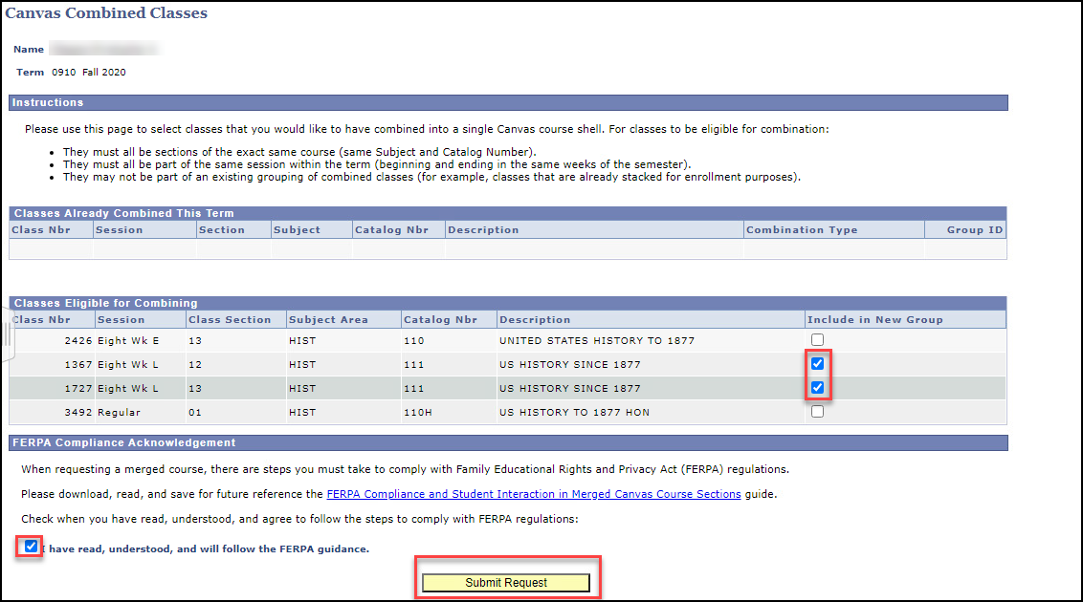

* Click OK.

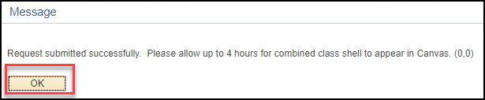

* If successful, your combined classes will now display under **Classes Already Combined This Term.**
* Click Faculty Center to exit this page.

